HOSPITAL
MANAGEMENT
SYSTEM

Index

- Introduction

- Objectives

- Features

- Class Diagrams

- Layouts of different screens

- Welcome Screen

- Admin portal

- Doctor Management

- Receptionist Management

- Doctors Portal

- Receptionist Portal

- Adding Patient

- Creating Appointment

Documentation on Hospital Management System
A Hospital Management System(HMS) is a computer based system that facilitates managing the functioning of the hospital.
In Hospitals they are collecting data on storing information on paper and it is a time taking process and communication between staff is difficult.
By using this HMS we can store data of patients digitally and we are able to transfer the data easily like creating appointments and various operations on patients like adding, updating, deleting, searching etc.
Objectives of HMS

- Computerisation: All the records of hospitals are computerised it doesnt matter small or big.

- Keeps the Records: If it is connected to database the records can be maintained.

- Appointment: It will be easier for both the doctors and the patients to have the appointments.It is just adding id to the doctor.

- Security: It asks login name and password to enter into their portals so it is difficult to get in by unauthorised user.

Features of HMS

- Multi user account system.

- Managing all types of user’s accounts.

- Adding patients information.

- Managing patients data.

- Appointment management.

- Viewing appointments.

Class Diagram of HMS

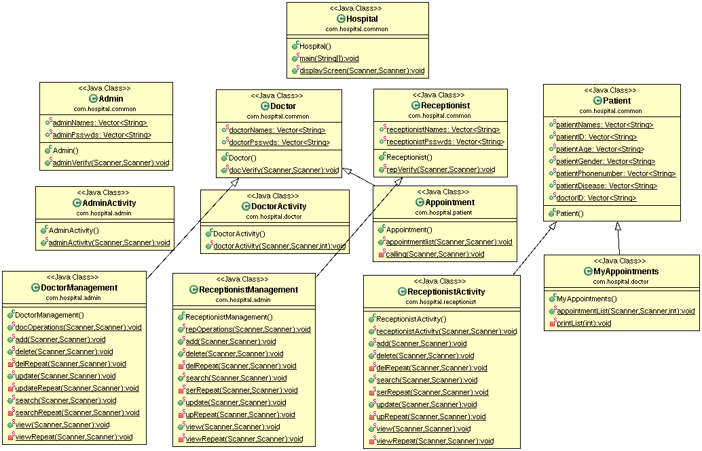

1.WelcomeScreen

This is the initial screen displayed when the system is lanuched.

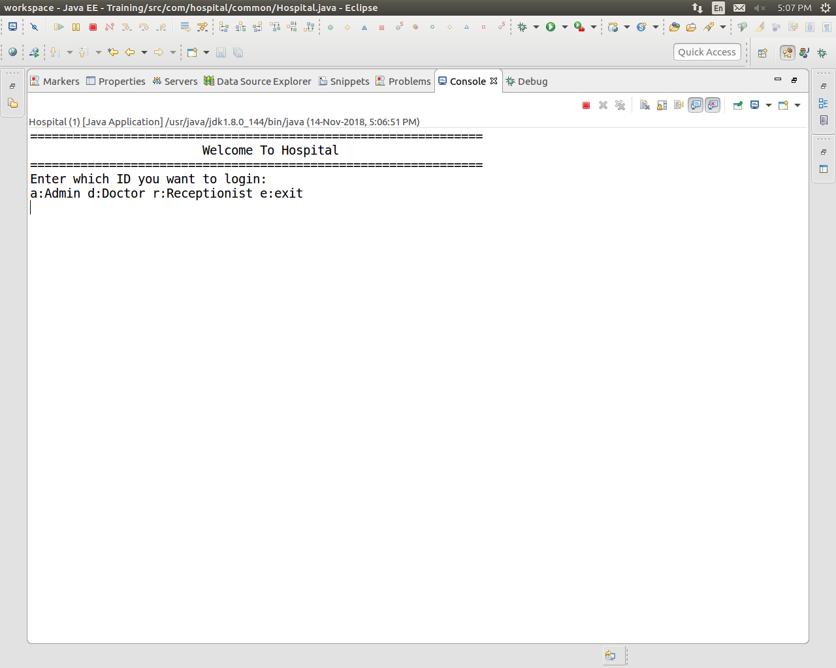
Here we have to enter which we want to login
‘a’ for Admin
‘d’ for Doctor
‘r’ for Receptionist
‘e’ for Exit.

2.AdminPortal

After Entering valid Name and Password the Portal will be

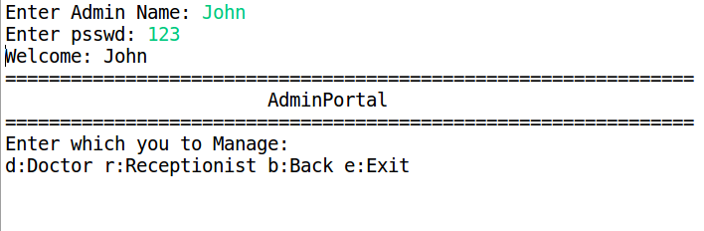
Here we have to enter which one we want to manage either Doctor or Receptionist
‘d’ for Doctor Management
‘r’ for Receptionist Management
‘b’ to go to previous window
‘e’ to exit.

3.Doctor Management

If Doctor Management is selected then it displays

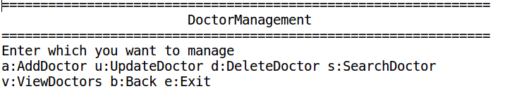
It ask which one we want to manage and there are various options through which we can perform ‘adding a new Doctor details’ or ‘updating the previous details of Doctor’ or ‘deletion of Doctor’ or ‘we can search a Doctor’ or ‘we can view details of all Doctors’.
For all these we have enter an option.

4.Receptionist Management

If Receptionist Management is selected then it displays

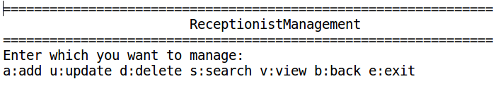
It ask which one we want to manage and there are various options through which we can perform ‘adding a new Receptionist details’ or ‘updating the previous details of Receptionist’ or ‘deletion of Receptionist’ or ‘we can search a Receptionist’ or ‘we can view details of all Receptionists’.
For all these we have enter an option.

5.Doctors Portal

After Entering valid Name and Password the Portal will be

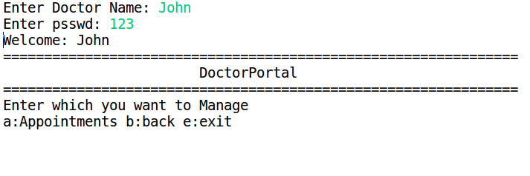
Here Doctor can able to see his appointment list
‘a’ for Appointments he has
‘b’ to go to previous window
‘e’ to exit.

6.Receptionist Portal

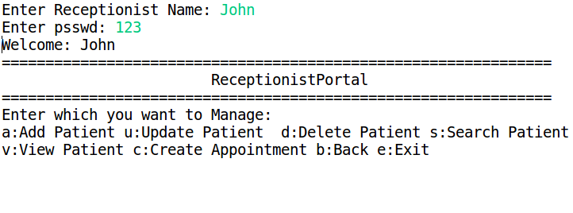
After Entering valid Name and Password the Portal will beIt ask which one we want to manage and there are various options through which we can perform ‘adding a new Patient details’ or ‘updating the previous details of Patient’ or ‘deletion of Patient’ or ‘we can search a Patient’ or ‘we can view details of all Patients’.
For all these we have enter an option.
And in this Receptionist can create appointments to doctors .

7.Adding Patient

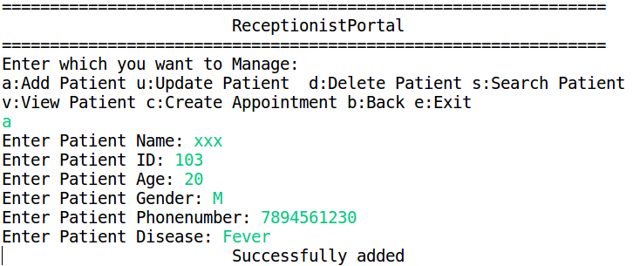
After selecting add patient it collects these details

In adding new Patient it asks to enter Patient Name, Patient ID, Patient Age, Patient Gender, Patient Phone Number and the disease of the Patient suffering with.

8.Creating Appointment

After adding patient we have to create an appointment for a doctor and the page looks like this

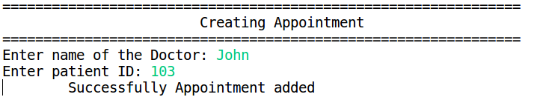

Here we have to give the name of the doctor to create appointment and ID of the patient.

